**Ideation Phase**

**Define the Problem Statements**

|  |  |
| --- | --- |
| Date | 31 January 2025 |
| Team ID | LTVIP2025TMID54121 |
| Project Name | revolutionizing liver care |
| Maximum Marks | 2 Marks |

**Customer Problem Statement Template:**

A **Customer Problem Statement Template** is a structured format that helps identify and clearly articulate the **real issues or pain points** faced by patients, caregivers, or healthcare providers in the context of **liver care**. In the journey to revolutionize liver care, this tool is crucial for ensuring that innovation efforts are **rooted in real needs** rather than assumptions.

### ✅ Why Use a Customer Problem Statement in Liver Care?

* Focuses innovation efforts on **real-world problems**
* Helps align teams (clinicians, researchers, tech, business) on a **common goal**
* Drives empathy for **patients, caregivers, and doctors**
* Acts as a foundation for **solution ideation and validation**

### 🧩 Template: Customer Problem Statement (Liver Care Focus)

Here’s a structured template with guiding questions:

#### ****1. Customer Segment****

**Who is experiencing the problem?**  
(e.g., Chronic liver disease patients, caregivers, hepatologists, primary care physicians)

Example: Patients with non-alcoholic fatty liver disease (NAFLD)

#### ****2. Problem Description****

**What is the core problem or pain they are experiencing?**  
Focus on symptoms, inefficiencies, or emotional struggles.

Example: Patients often don’t get diagnosed until late-stage liver disease because early symptoms are vague and routine screening is not emphasized.

#### ****3. Context / Environment****

**When and where does the problem occur?**  
Look at workflows, settings (home, clinics), or technology gaps.

Example: In primary care settings where liver health is not proactively monitored.

#### ****4. Current Alternatives / Workarounds****

**How is the problem currently being handled? What are the limitations?**

Example: Liver function tests are ordered only when liver disease is suspected; many cases go undetected in early stages.

#### ****5. Consequences of the Problem****

**What is the impact of this problem if it is not solved?**

Example: Late diagnosis leads to higher treatment costs, worse outcomes, and increased

#### ****6. Emotional / Human Insight****

**What are the emotional or behavioral insights about the user?**

Example: Patients feel anxious due to lack of clarity about their liver health and feel neglected in preventive care conversations.

### 🎯 Example Statement

“Primary care patients with risk factors for liver disease (like obesity and diabetes) are not being proactively screened, leading to late diagnoses and avoidable complications. This occurs because liver care is often reactive, not integrated into routine checkups. As a result, patients feel overlooked, and doctors miss early intervention opportunities.”

### 📌 Tips for Writing an Effective Statement

* **Use real quotes or observations** from interviews, if available.
* Avoid suggesting solutions – focus only on defining the **problem**.
* Be concise but **rich in context and empathy**.
* Revisit and refine the statement as you gather more insights.

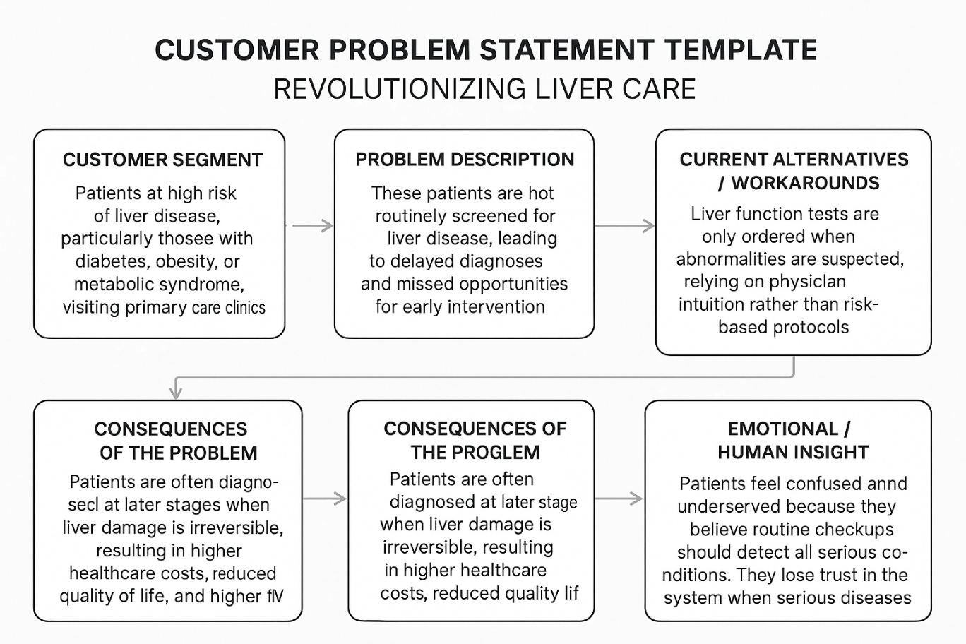

**Example:**

### ✅ ****Example 1: Early Detection in Primary Care****

* **Customer Segment**: Adults with obesity, diabetes, or metabolic syndrome visiting general practitioners.
* **Problem Description**: These high-risk patients are not routinely screened for liver disease in primary care settings.
* **Context**: Liver function assessment is often overlooked during regular checkups due to lack of standard screening protocols.
* **Current Workarounds**: Tests are only ordered based on visible symptoms or abnormal labs, which often appear too late.
* **Consequences**: Late diagnosis of conditions like NAFLD/NASH leads to irreversible liver damage and increased treatment burden.
* **Emotional Insight**: Patients assume annual checkups cover major health risks, leading to confusion and frustration when liver disease is diagnosed unexpectedly.

### ✅ ****Example 2: Post-Transplant Follow-up Gaps****

* **Customer Segment**: Liver transplant recipients and their caregivers.
* **Problem Description**: Patients struggle to manage complex follow-up care after transplant, leading to complications.
* **Context**: Post-discharge care is fragmented, with poor communication between transplant centers and local providers.
* **Current Workarounds**: Patients rely on handwritten notes, multiple apps, or informal caregiver support.
* **Consequences**: Medication non-adherence, missed appointments, and preventable hospital readmissions.
* **Emotional Insight**: Patients feel overwhelmed, anxious, and unsupported during a critical recovery period.